1.Find student average mark gven mark 1 and mark 2.
input-mark1 and mark2 output-average mark
Step 1:Start
Step 2:Declare values mark1,mark2 and avg
Step 3:Read values mark1 and mark2 and find sum
sum←mark1+mark2
Step 4:Divide the sum by 2 and assign the result in avg
avg←mark1+mark2/2
Step 5:Display avg
Step6 :Stop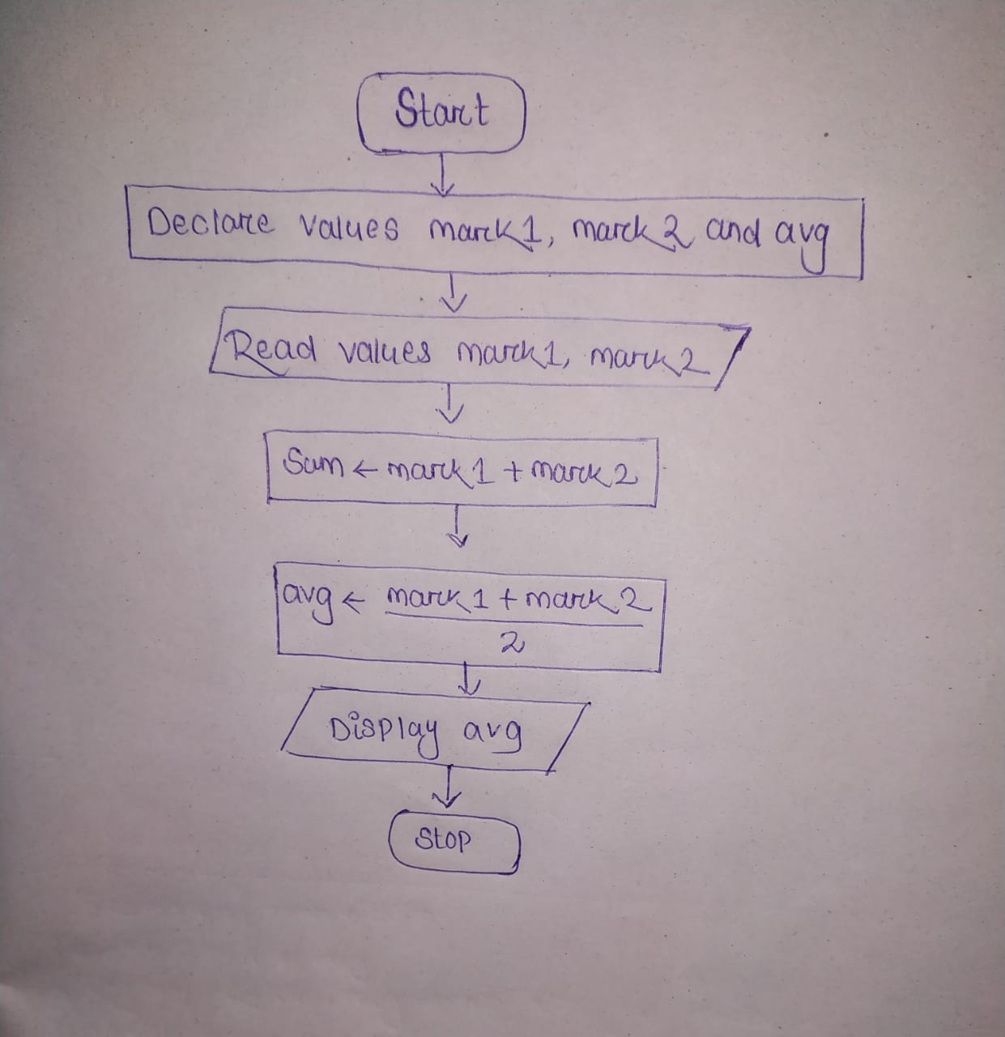

- Calculate the total fine charged by library for late return books.The charge is 0.20 INR for a day.
input-issue date,return date and charge output-total fine
Step 1:Start
Step 2:Declare days,initialize charge and fine
Step 3:Read issued date and return date and charge
Step 4:subtract return date and issue date and find number of days
number of days←return date-issued date
Step 5:Multiply the charge per day and number of days and assign the result in fine
fine←charge per day*number of days
Step 6:Display fine
Step7:Stop
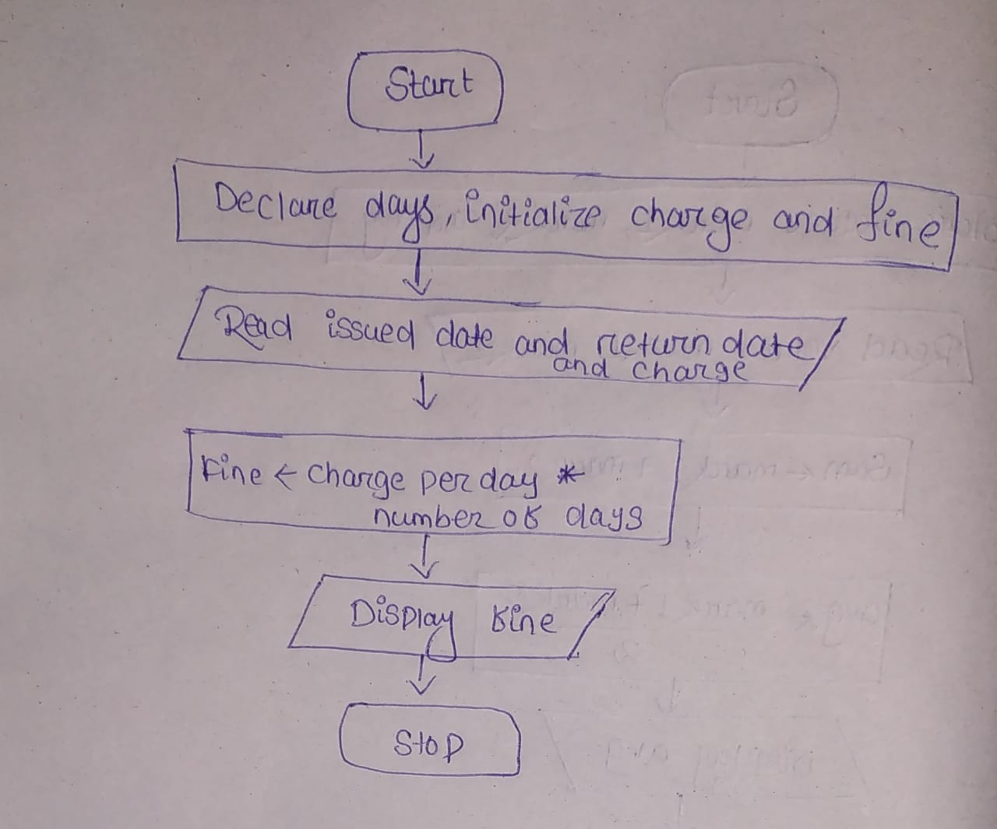

3.you had bought a nice shirt which cost is Rs29.90 with 15% discount.Count the net price for the shirt.
Input-cost and discount output-net price
Step 1:Start
Step 2:Declare cost,discount and net price
Step 3:Read cost and discount
Step 4:Multiply the discount and cost and find the discount cost
discount cost←0.15*cost
Step 5:subtract the actual cost and discount cost and assign the result in net price
net price←cost-discount cost
Step 6:Display net price
Step 7:Stop
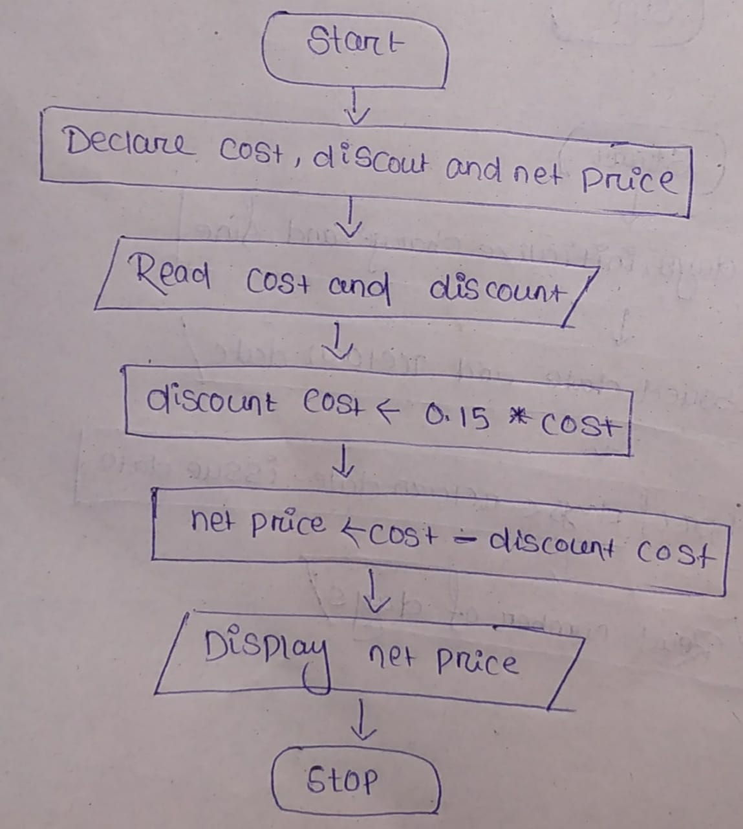

4.Find th smallest number among three different numbers.
Step 1:Start input-variable a,b,c
Step 2:Declare 3 variables a,b,c output-smallest number
Step 3:Read variables a,b and c
Step 4: if a<b
if a<c
Display a is the smallest number
Else
Display c is the smallest number
Else
if b<c
Display b is the smallest number
Else
Display c is the smallest numer
Step 5:Stop
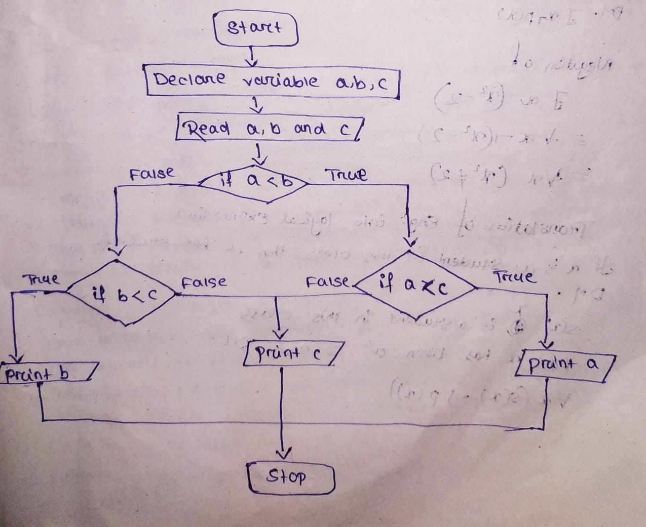
- Find the roots of a quadratic equation ax²+bx+c=0 .
input-variable a,b,c output-roots x1,x2
Step 1:Start
Step 2:Declare variables a,b,c
Step 3:Read variables a,b,c
Step 4:Find the value of D using the formula
d←sqrt(b*b-4*a*c)
Step 5:If D is greater than or equal to zero find 2 roots
x1←(-b+sqrt(d))/(2*a)
x2←(-b-sqrt(d))/(2*a)
Step 6:Display x1,x2
Step 7:If D is less than zero ,then print No real solutions
Step 8:Stop
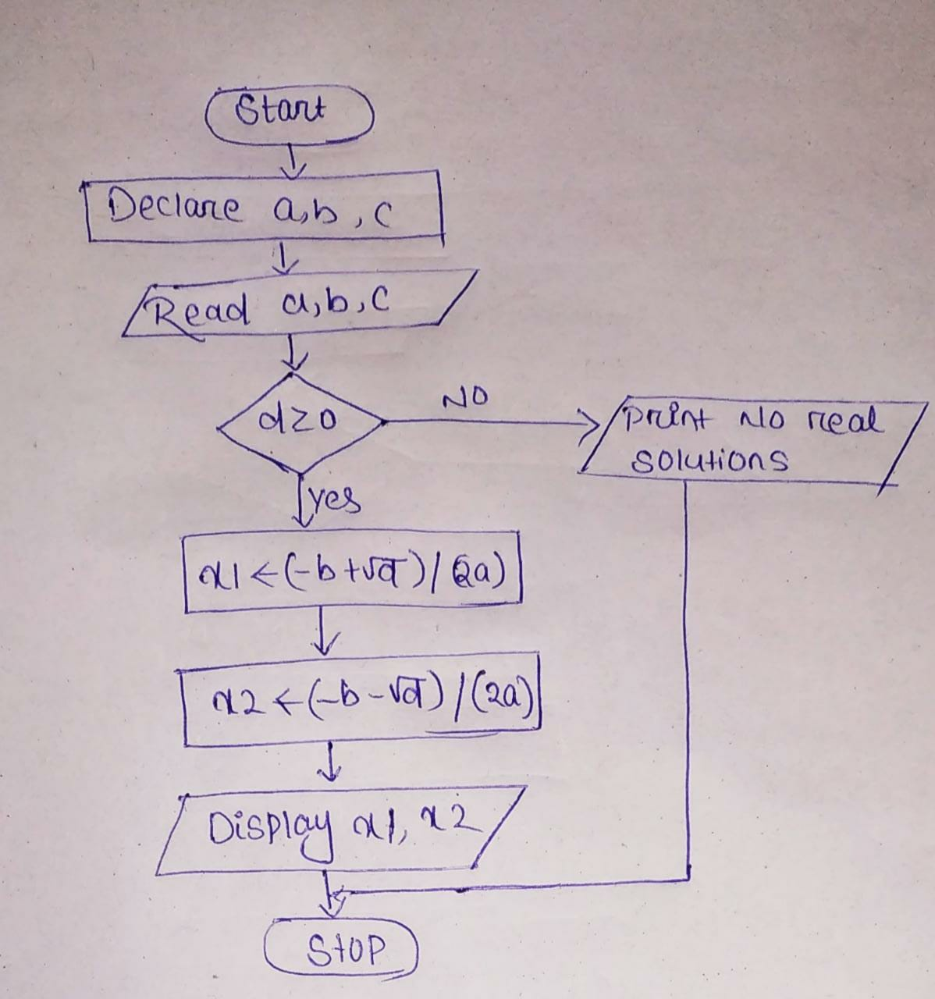

- Find the factorial of a given number.
Input-variable num,i,fact output-fact
Step 1:Start
Step 2:Declare the variable i,fact,num
Step 3:Read the value of num
Step 4:Initialize counter variable i to 1 and fact to 1
Step 5: if i<=num go to step 6 otherwise goto step 7
Step 6: Fact←fact*i
Step 7:increment counter variable i and go to step 5
Step 8:Display fact
Step 9:Stop
